To turn raw audio buffers into the "Liquid Glass" directional UI you're envisioning for VigilantEar, we need to process the signal through three distinct architectural layers.
Since the M4 MacBook Air features a high-bandwidth Neural Engine and a sophisticated triple-mic array, you can handle these calculations in real-time with zero latency.

The Signal Processing Flowchart
- Ingestion Layer (Hardware)
  - The triple-mic array captures raw PCM audio at 44.1kHz.
  - MicrophoneManager receives these buffers via an AVAudioEngine tap.
- Analysis Layer (The Physics)
  - Frequency Analysis (FFT): We run a Fast Fourier Transform to identify the dominant frequency. If a 1000Hz siren shifts to 1050Hz, the Doppler Effect confirms an approach.
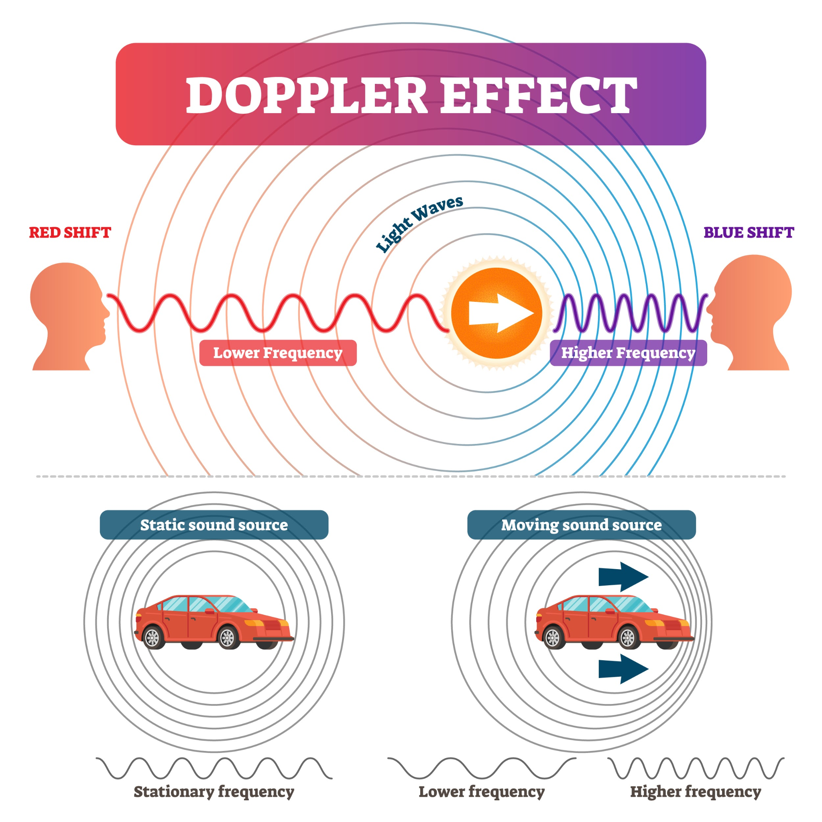

* **Phase Correlation (TDOA):** We compare the micro-second delay between the top and bottom microphones. By calculating the Time Difference of Arrival ($\Delta t$), we can determine the Angle of Arrival ($\theta$).
- Classification Layer (AI)
  - The buffer is sent to a Core ML model (trained on SoundAnalysis) to confirm if the noise is a "Motorcycle," "Siren," or "General Traffic."
- Presentation Layer (UI)
  - The confirmed Classification, Vector (Angle), and Intensity (dB) are pushed to your SwiftUI View.
  - The "Liquid Glass" arrow rotates and pulses based on these live values.

Architectural Design Summary
Component | Responsibility | Physics/Logic
Input Tap | Raw Buffer Capture | AVAudioPCMBuffer
FFT Processor | Pitch Tracking | $\Delta f = f_s (\frac{v}{v \mp v_s})$
Phase Matcher | Directional Heading | $\theta = \arccos(\frac{v_s \cdot \Delta t}{d})$
Core ML | Object Identification | Audio Classification Model

